GESCOM SRTPV ONLINE APPLICATION PROCEDURE
1.LOGIN TO GESCOM SRTPV PORTAL
2:SELECT APPLY ONLINE (SOURA GRAHA YOJANE)
3:ENETER ACCOUNT ID AND ACCEPT TERMS AND CONDITIONS
4:FETCH ACCOUNT ID DETAILS
5:ENTRY THE ALL FIELDS AND SUBMIT
6:CONFIRM THE DETAILS ENTERED AND CLICK OK
7:OTP WILL GENERATE TO THE GIVEN PHONE NUMBER CLICK OK
8:ENTER THE OTP AND SUBMIT
NOTE DOWN REGISTERED APPLICATION NUMBER FOR FURTHER USE
9:REDIRECTS TO PAYMENT PAGE SELECT THE PAYMENT MODE THEN MAKE PAYMENT
10:PAYMENT STATUS
11:TRACK YOUR REGISTERED APPLICATION BY ENTERING APPLICATION NUMBER AND REGISTERED MOBILE NUMBER
12:APPLICATION STATUS
13:APPLICARTION IS REGISTERED PENDING FOR FEASIBILITY
14:GO TO OFFICER LOGIN
15:CHECK THE NO.OF APPLICATION REGISTERED IN CONCERNED SUBDIVISION OFFICE
16:CLICK ON THE REQUIRED APPLICATION ID AND GO TO FEASIBILITY OPTION
17:DOWNLOAD UNSIGNED FEASIBILITY REPORT
18:TAKE THE PRINT AND GET IT SIGNED BY CONCERNED OFFICER
19:UPLOAD THE SIGNED FEASIBILITY REPORT AND SUBMIT
20:FEASIBILITY SUBMITTED SUCCESSFULLY CLICK OK
21:DOWNLOAD THE SIGNED FEASIBILITY REPORT

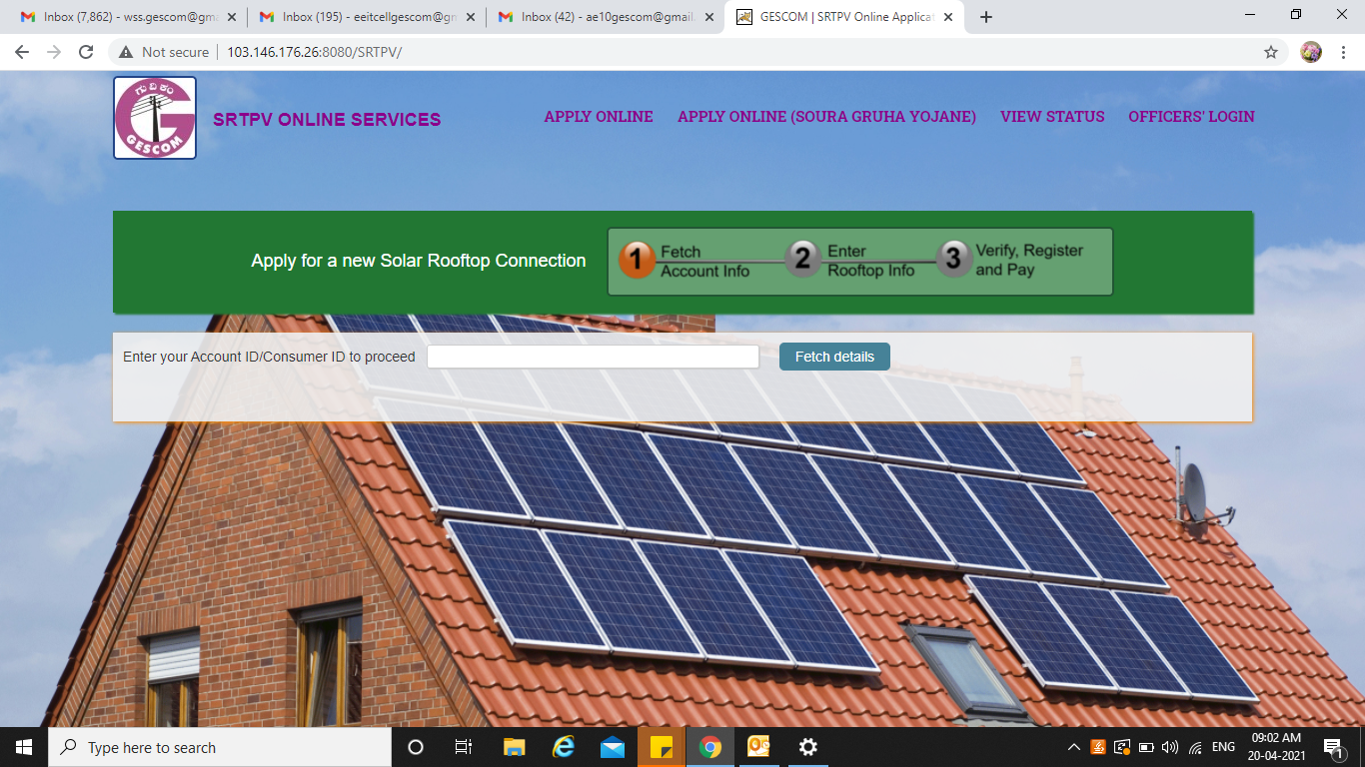
1:LOGIN TO GESCOM SRTPV PORTAL

2:SELECT APPLY ONLINE (SOURA GRAHA YOJANE)

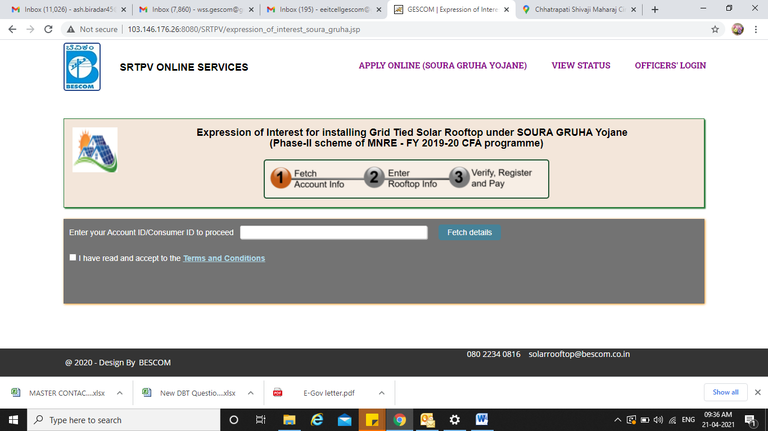

3:ENETER ACCOUNT ID AND ACCEPT TERMS AND CONDITIONS

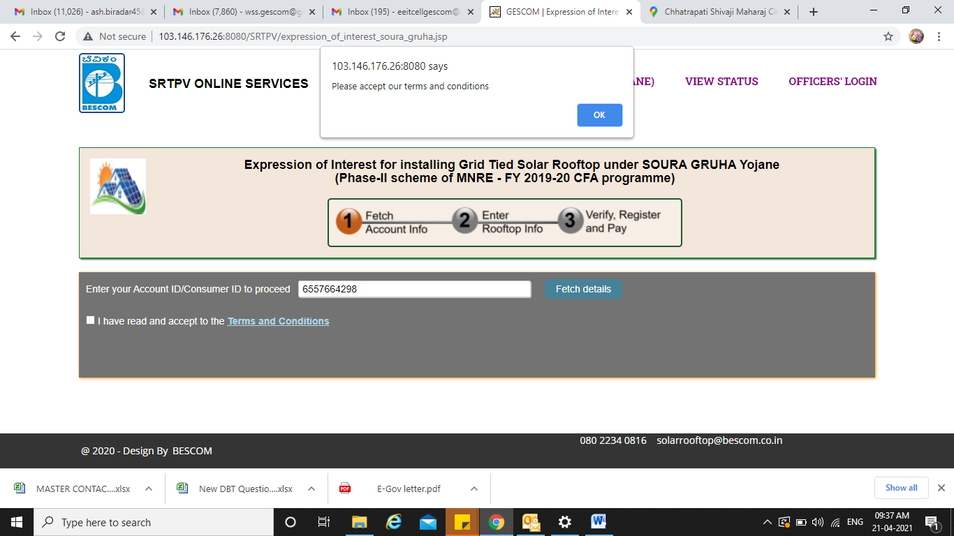

4:FETCH ACCOUNT ID DETAILS
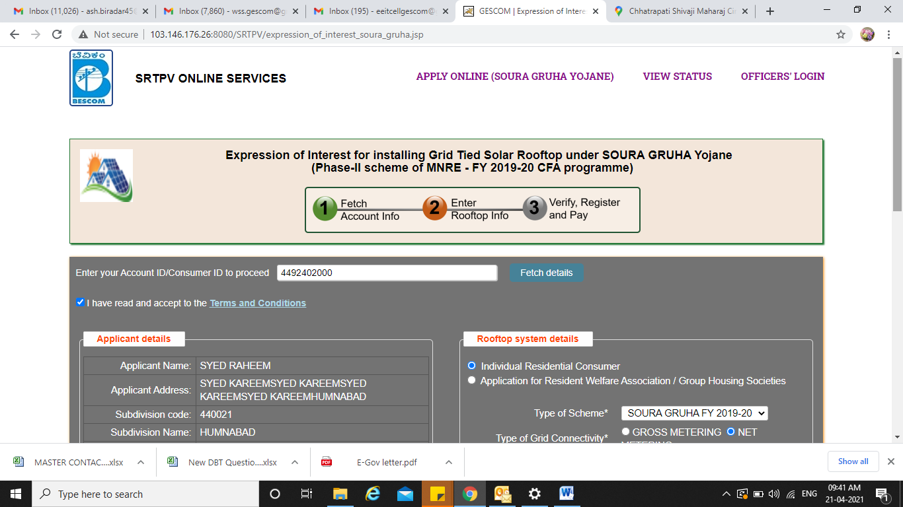

5:ENTRY THE ALL FIELDS AND SUBMIT
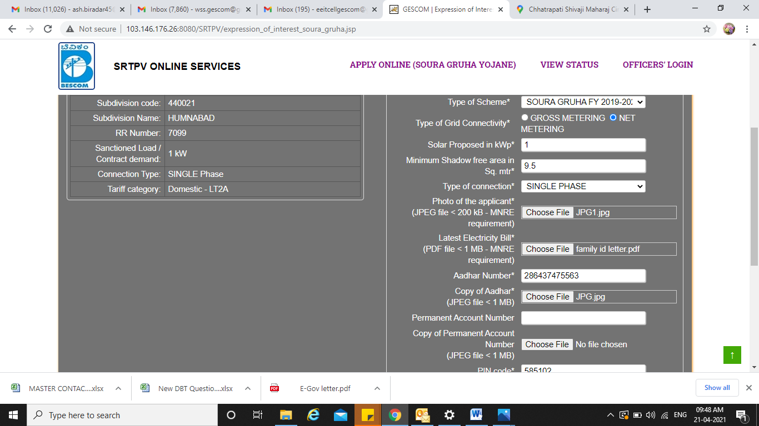

6:CONFIRM THE DETAILS ENTERED AND CLICK OK
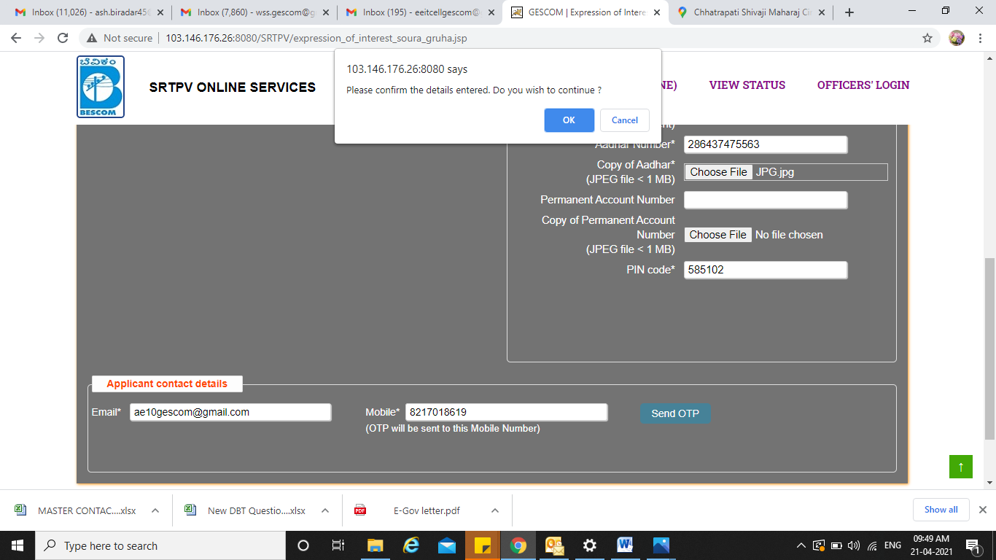

7:OTP WILL GENERATE TO THE GIVEN PHONE NUMBER CLICK OK
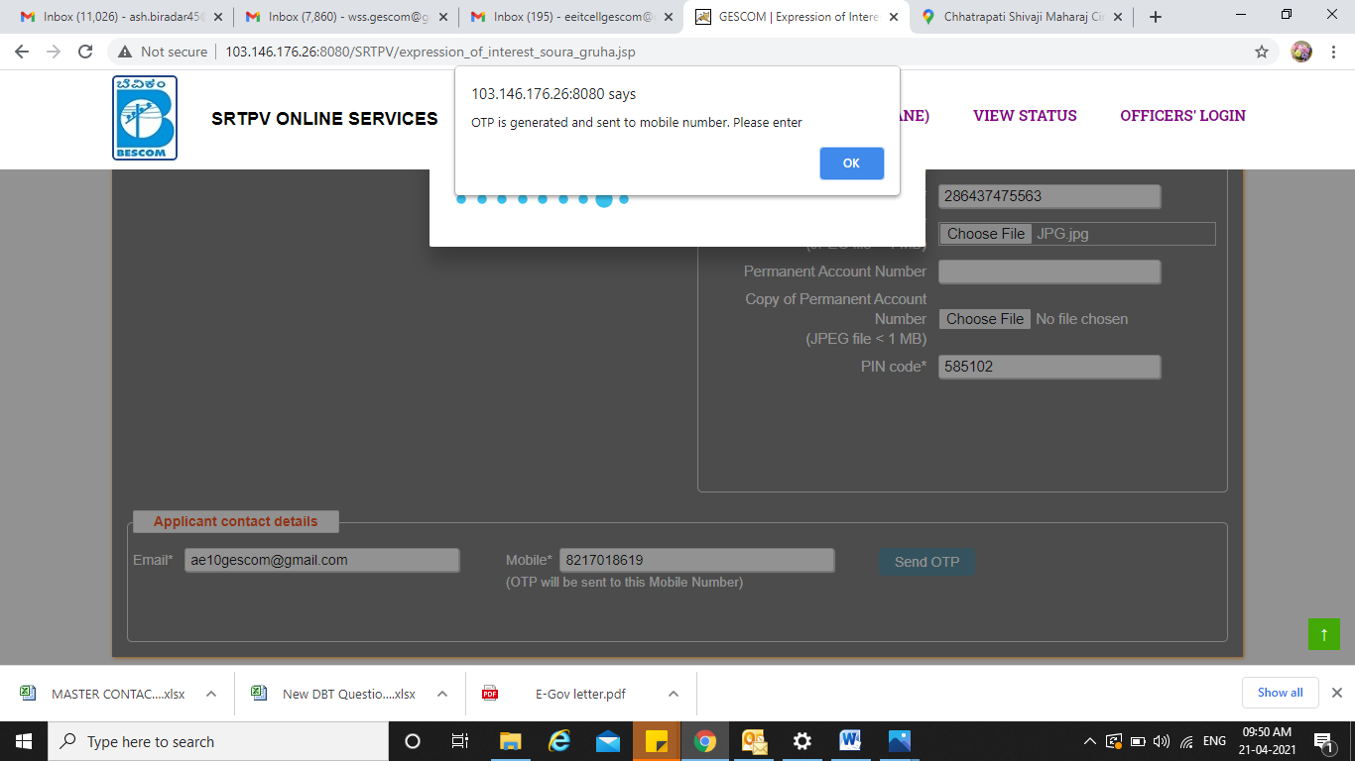

8:ENTER THE OTP AND SUBMIT
NOTE DOWN REGISTERED APPLICATION NUMBER FOR FURTHER USE
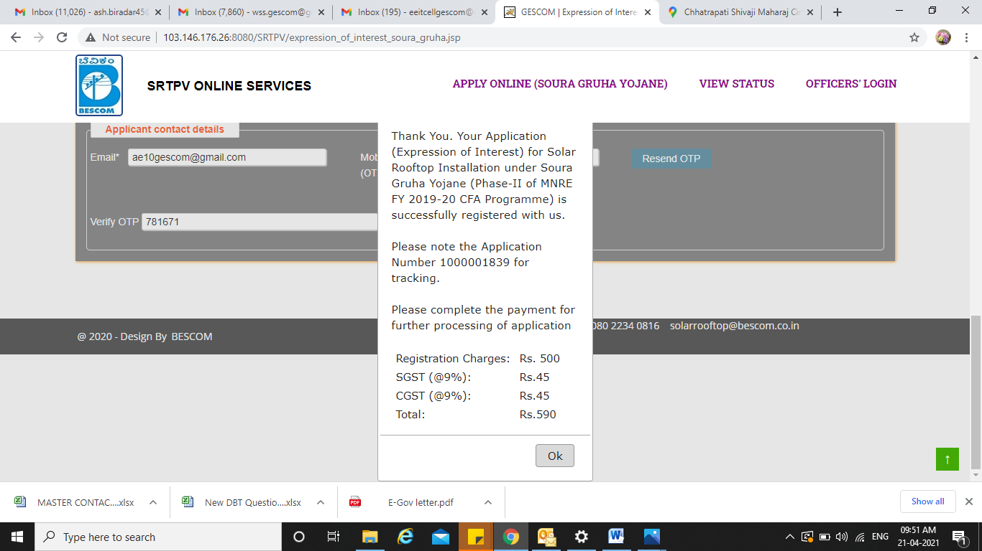

9:REDIRECTS TO PAYMENT PAGE SELECT THE PAYMENT MODE THEN MAKE PAYMENT
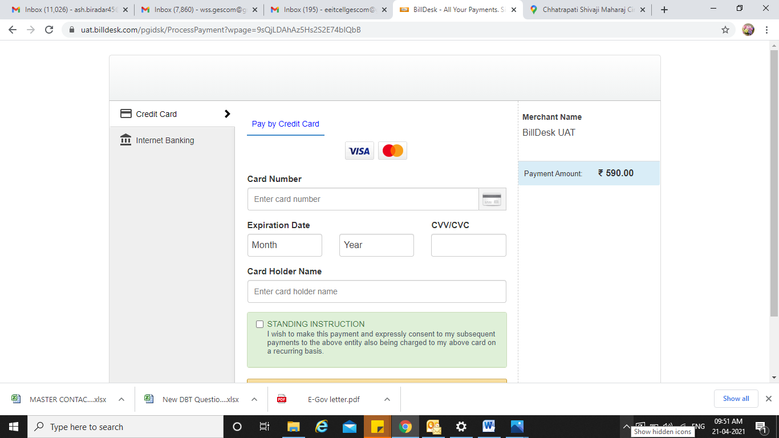
10:PAYMENT STATUS
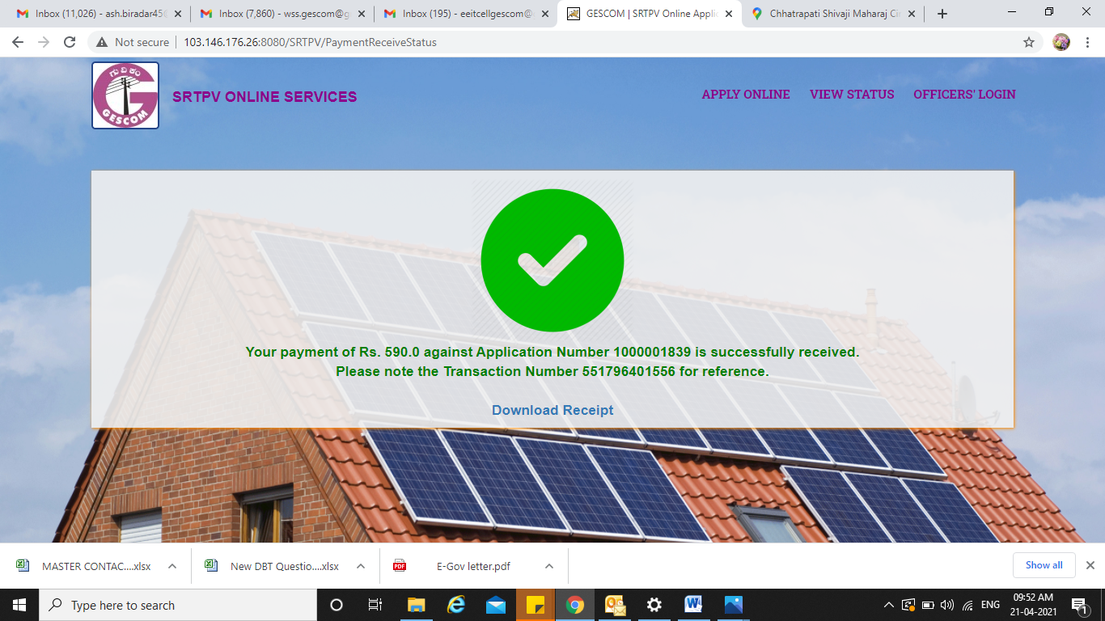

11:TRACK YOUR REGISTERED APPLICATION BY ENTERING APPLICATION NUMBER AND REGISTERED MOBILE NUMBER
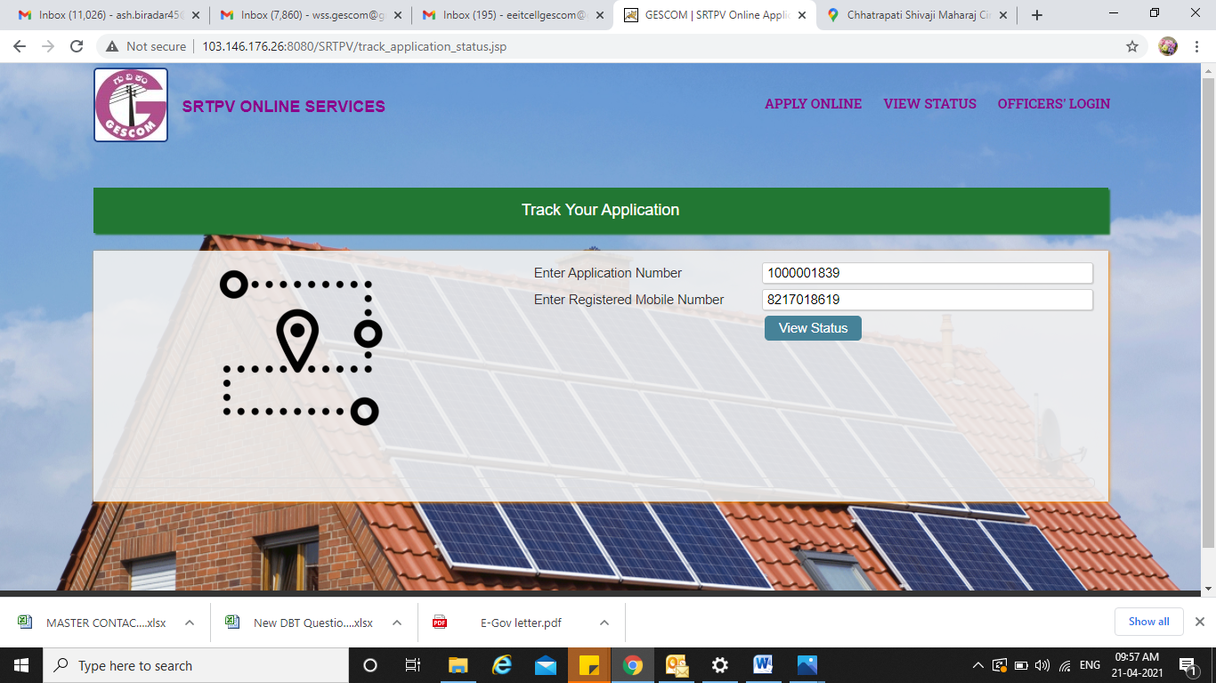

12:APPLICATION STATUS
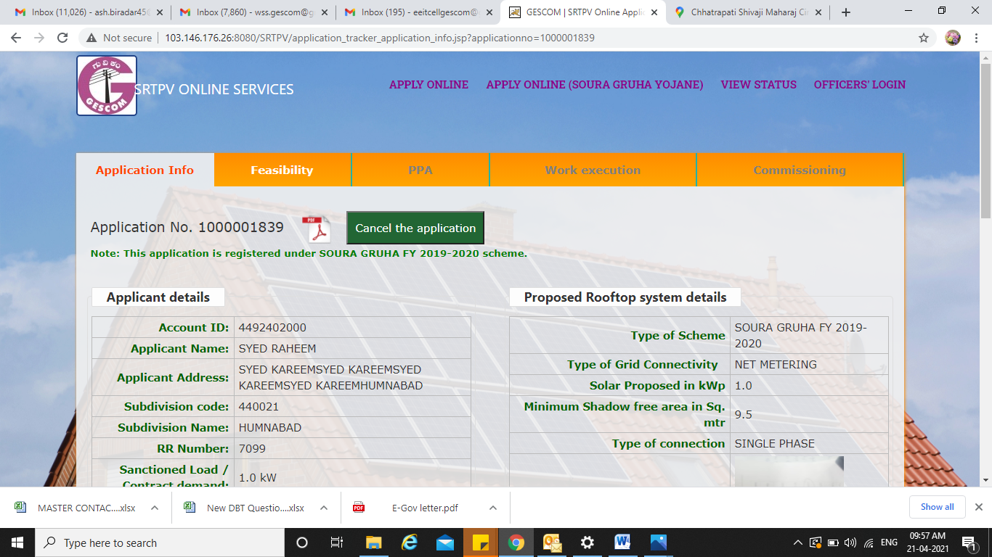
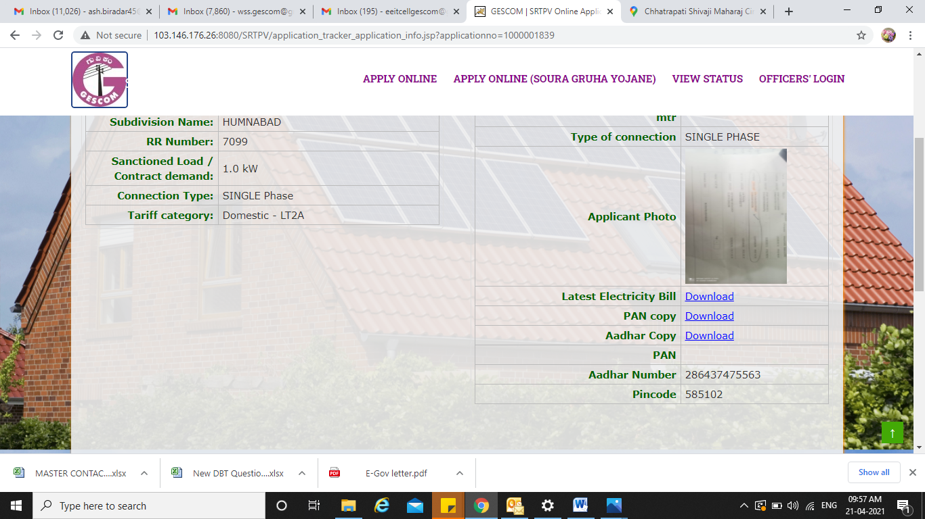

13:APPLICARTION IS REGISTERED PENDING FOR FEASIBILITY
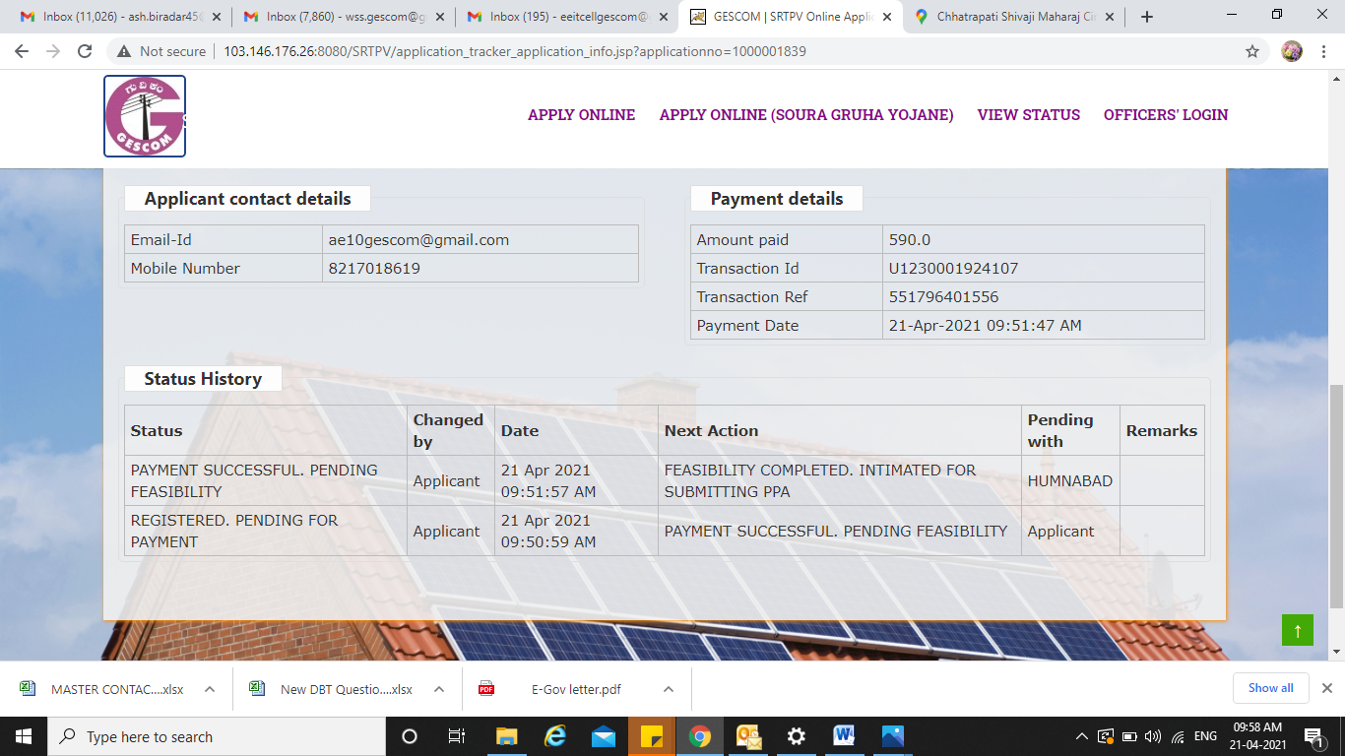

14:GO TO OFFICER LOGIN
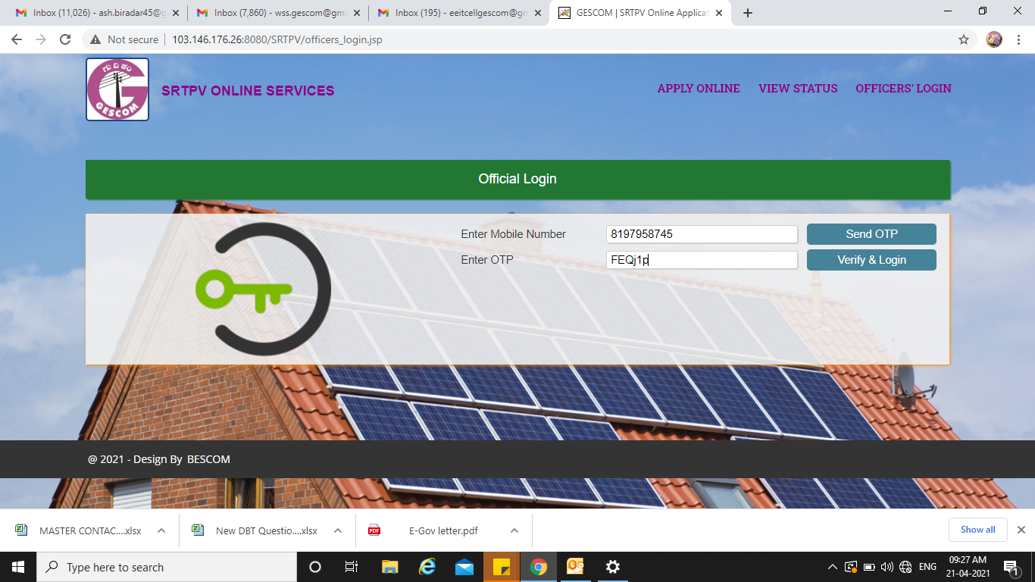

15:CHECK THE NO.OF APPLICATION REGISTERED IN CONCERNED SUBDIVISION OFFICE

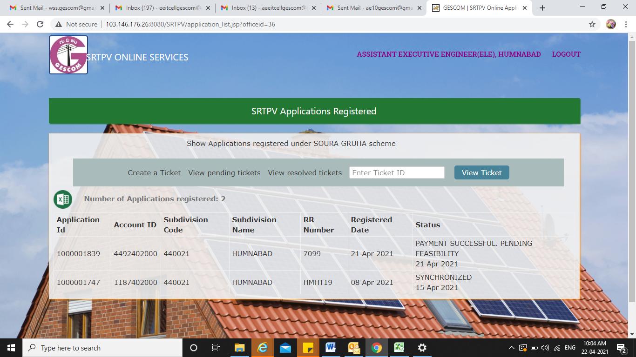

16:CLICK ON THE REQUIRED APPLICATION ID AND GO TO FEASIBILITY OPTION

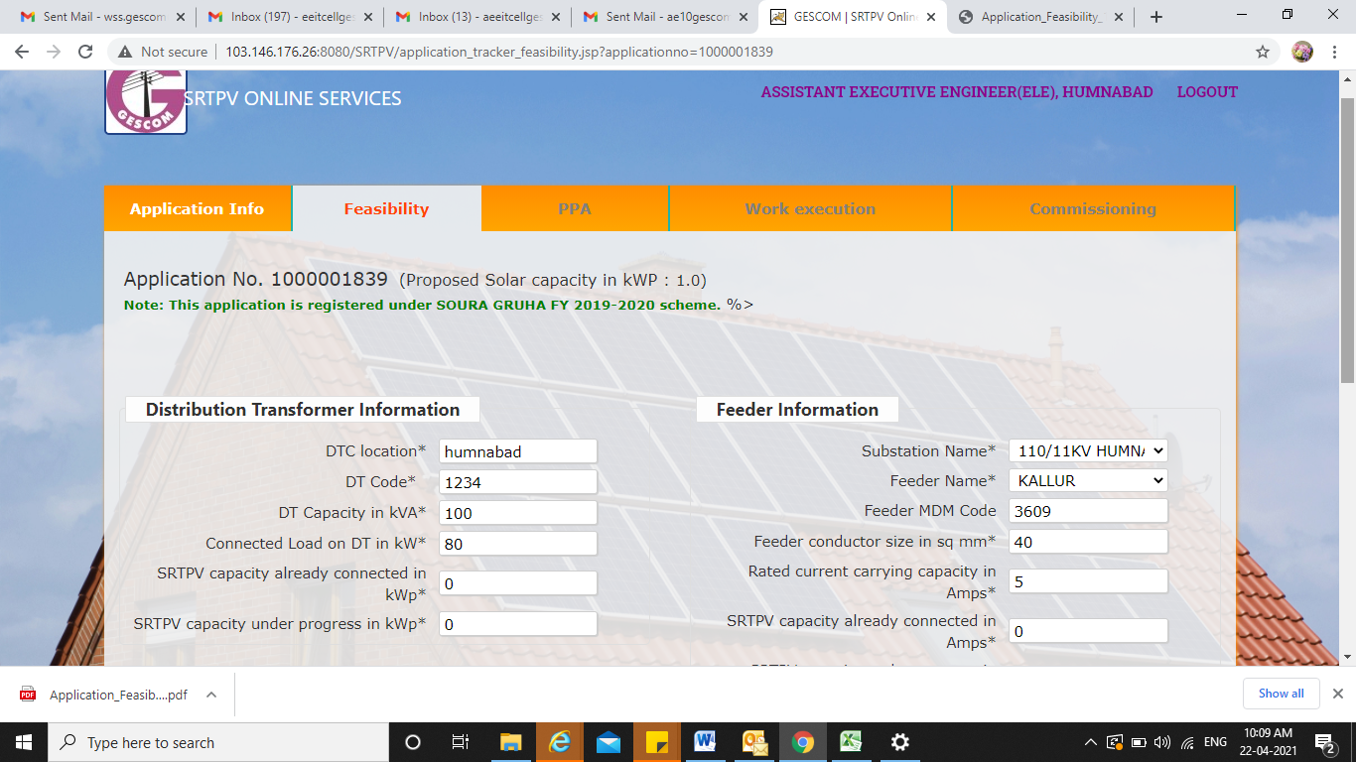

17:DOWNLOAD UNSIGNED FEASIBILITY REPORT
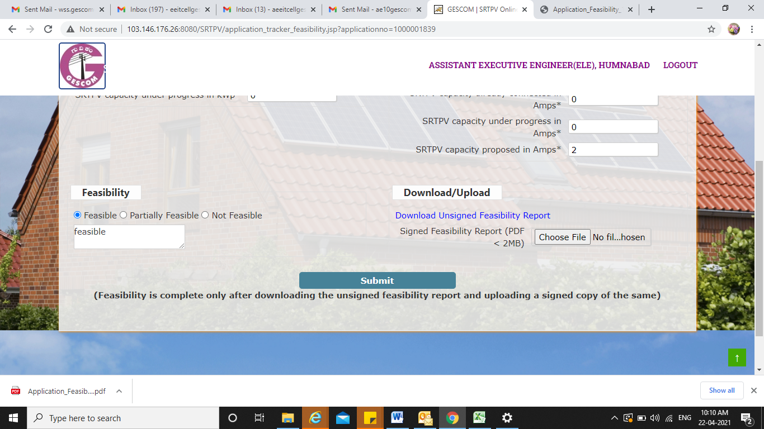

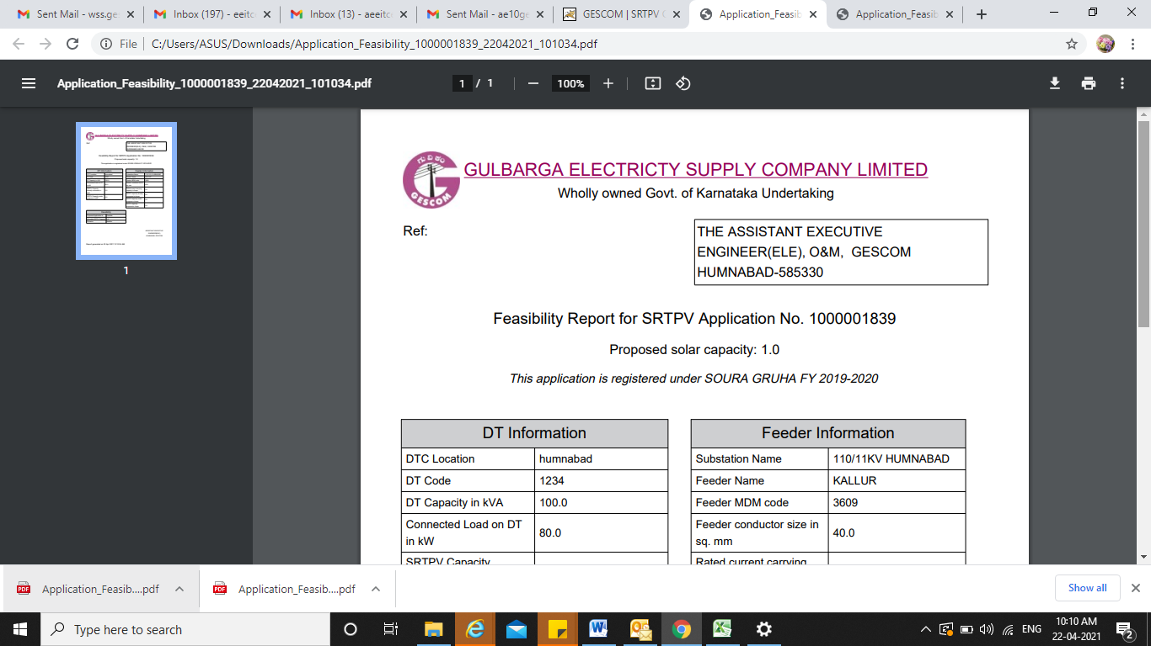

18:TAKE THE PRINT AND GET IT SIGNED BY CONCERNED OFFICER
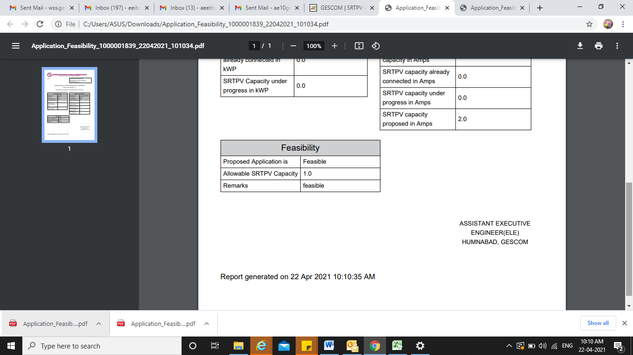

19:UPLOAD THE SIGNED FEASIBILITY REPORT AND SUBMIT
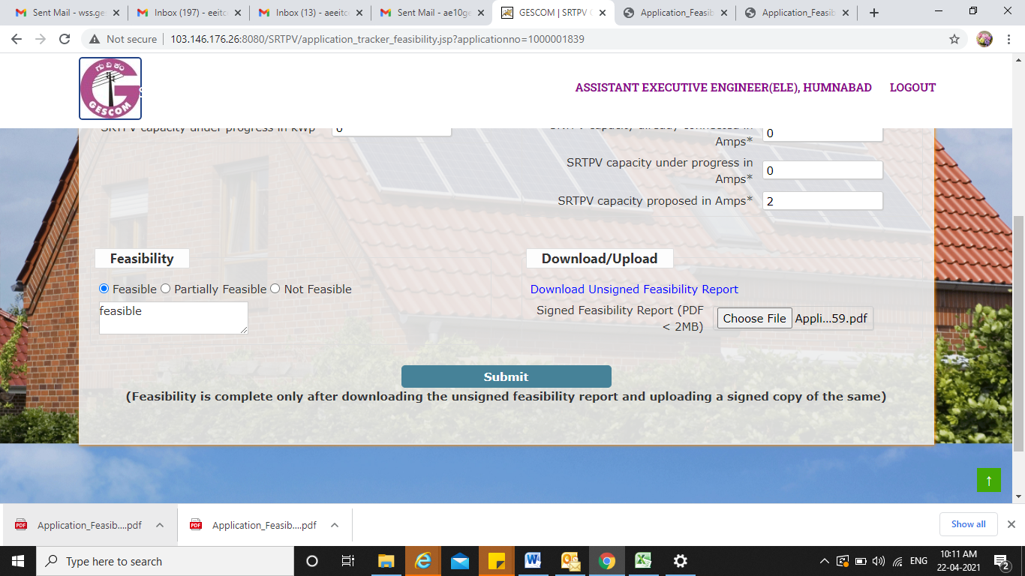

20:FEASIBILITY SUBMITTED SUCCESSFULLY CLICK OK
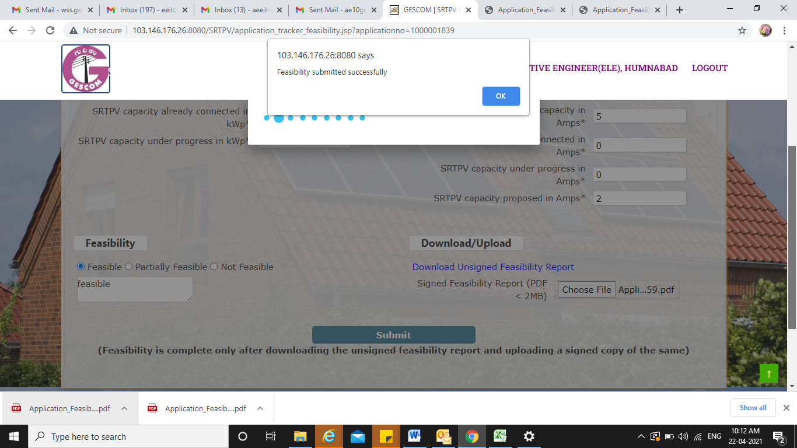

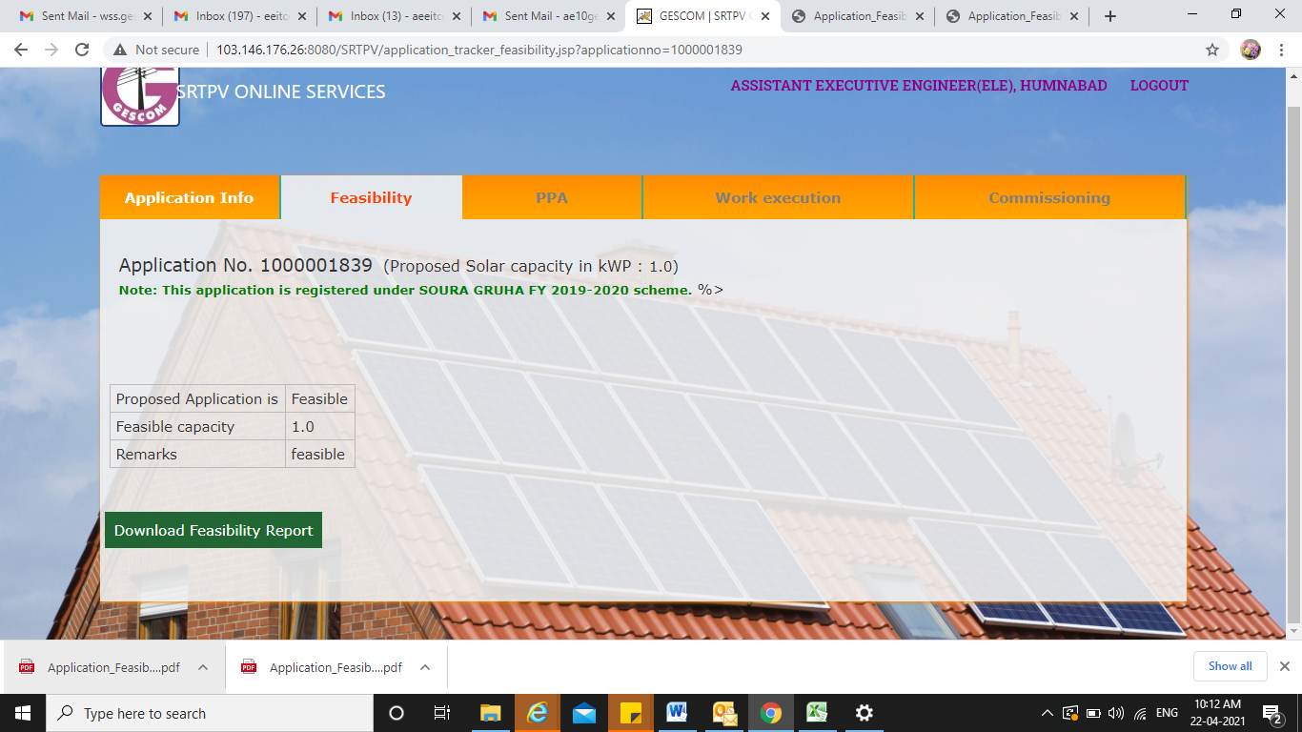

21:DOWNLOAD THE SIGNED FEASIBILITY REPORT
